Master Thesis

Topic for Student Project
Published Date: May 01, 2022

Description

Describe the background and goals of this work here..

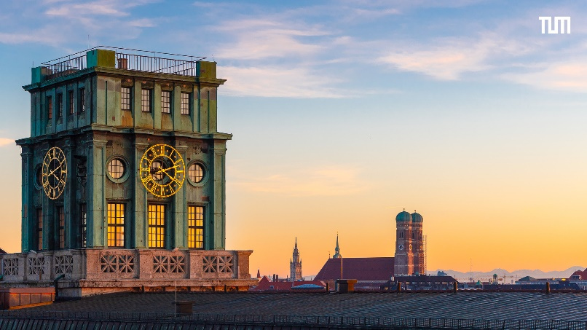
Tasks
Describe the tasks
- Task 1;
- Task 2;
- Task 3;
- Task 4.
Prerequisites
List the reeuiqremnts.
- Great interest in power electronics;
- Skill 1;
- Skill 2;
- Skill 3.
Contact and further information
- Please attach your CV and the latest study transcript to the application
M.Sc. Max Mustermann

Technical University of Munich
Chair of High-Power Converter Systems
Arcisstr.21, 80333 Munich
name.surname@tum.de
www.epe.ed.tum.de/eal

